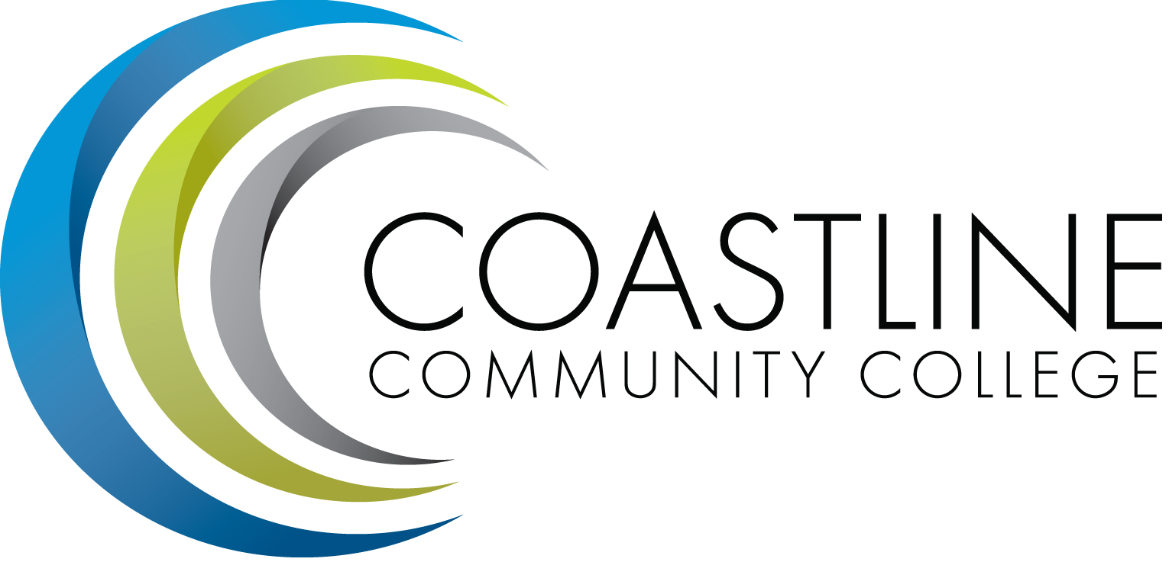
Technology Committee Agenda
04/19/2018, 3:00 p.m. – 5:00 p.m.
College Center – 4th Floor Conference Room

Committee Mandate: This committee is responsible for the development and evaluation of a Technology Master Plan. The committee is also responsible for:
- The development of long and short range plans and priorities for CCC to facilitate the acquisition and deployment of technology
- The review, evaluation and recommendation regarding existing and emerging technologies that will enhance student learning and improve communication and computing technologies at Coastline

- CALL TO ORDER
  - Welcome
  - Adoption of Agenda: 04/19/2018
  - Approval of Minutes: 02/22/2018
- REPORTS
2.1 Upcoming network outage – R. Looney
2.2 Migrating email to Cloud – R. Looney
2.3 Application streaming – R. Looney

- DISCUSSION
3.1 Technology Master Plan

- ACTION ITEMS
  - From October 19, 2017 Meeting:
    - Dave Thompson to obtain a list of all software offered to students and staff and supported by District IT. He will also request DIT’s definition of support. Dave has begun to compile list and will provide a full list at the next meeting. – ONGOING
    - Dave Thompson will send an email to Shelley Blair requesting scope of what is wanted and how (to provide knowledge –based assistance to students during off hours) it will be used and to ask if she would like to defer the discussion to Aeron Zentner. Dave will attempt to attain additional funding from the District budget. – ONGOING
  - From October 19, 2017 Meeting:
    - Provide a full list of District IT’s definition of support software for students and staff – Dave Thompson – Dave reported that the list consists of Microsoft Office and Adobe Creative Cloud. Other programs would be obtained by purchasing additional licenses. Questions about the software programs should be submitted to IT via a Help Desk Request. Dave and the committee discussed various software programs that are and are not currently supported by District IT. Dave will provide a list of software programs currently supported by District IT for the committee’s review. Dave will create a separate list of Coastline software programs supported by IT. FOLLOW-UP AT NEXT MEETING

- STANDING REPORTS
  - District IT Directors Meeting – Dave Thompson
  - District Technology Meeting – Dave Thompson
  - PIEAC
  - Academic Senate/FSC – Cheryl Chapman
  - Associated Student Government
  - Classified Senate
  - Canvas Work Group
- ANNOUNCEMENTS
- ADJOURNMENT
Next Meeting: May 17, 2018, 3:00-5:00 p.m., 4th Floor Conference room
*Attachment has been emailed.
**Attachment available at meeting.

